 | Create PT Survival Guide 2018/2019 | 

Create PT Overview
Goal of the Task: Create a programming project of your own design and then explain the purpose, process, algorithms and abstractions used to build it. You have 12 hours to complete this task.

What you Submit: (1) Video of running program (2) Written Responses to prompts 2a-d (3) PDF of program code

How you get a good score: The AP committee wants to see that you can:
- Design and write the code for a computer program with a topic of your choosing
- Describe how you identified and solved problems as you developed your program
- Write code for an algorithm and describe its purpose within your program
- Write code for an abstraction and describe its purpose within your program

Suggested Process in a Nutshell (see also the Sample Timeline on following pages):

Pick your project… Something small enough that you can design and write in only a few hours.
You should basically know ahead of time what the core algorithm will be.
Hours 1-2 | Develop a “good enough” program / prototype within 2 hours  - Evaluate whether you can finish what you set out to do, and adjust as necessary.  - Check progress for responses 2c and 2d - algorithms and abstraction.  - You should know what your algorithm and abstraction will be at this point.
Hours 3-7 | Keep coding and get to a stopping point with ~5 hours to go  - Your video and written responses will take time to make — you’ll want to make last minute improvements!
Hour 8 | Record your video and respond to 2a
Hours 9-10 | Write responses to 2b, 2c, 2d
Hours 11-12 | Prepare to submit  - Finalize program code and written responses and submit on the digital portfolio as three separate files.  - Video of running program (.mp4, .wmv, .avi, or .mov)  - Written Response to prompts 2a-2d (PDF)  - Program Code (PDF)

Algorithms on the Create PT (20 mins)

Is it a Good Algorithm?
Algorithm - College Board Definitions: Algorithms are precise sequences of instructions for processes that can be executed by a computer and are implemented using programming languages. Algorithms make use of sequencing, selection or iteration. People write programs to execute algorithms. Your algorithm must include two or more algorithms that work in combination to achieve some desired result. Finally it must integrate mathematical and/or logical concepts.

What it means: Algorithms are chunks of code that accomplish a task. To make sure your algorithm is a little complex and that you demonstrate your programming abilities the College Board has a few specific requirements.

- Something You Wrote: The entirety of the code you submit as your algorithm should be something that you wrote entirely on your own. You cannot submit code that a partner helped you write.

- Mathematical and/or Logical Concepts: Mathematical concepts means code where your app does some sort of mathematical computation (+, -, *, /, %). These are typically used when your program is making a calculation.
Logical concepts means code where you use logical or comparison operators (&&, ||, !, ==, !=, <, > <= >=). These are typically used in combination with if-statements where your program is making a decision.

- A Parent and Two Children: Your selected algorithm must have two included algorithms that work in combination to achieve some result. The best way to think about this is that you have a “parent” algorithm that requires two or more components that can stand on their own as independent “child” algorithms.
You should NOT submit three separate algorithms. Instead you should find one large task in your program that can actually be divided into two or more sub-tasks (for example: a large task might be making a user login screen; subtasks are (1) checking their login information (2) updating the screen appropriately). The code to accomplish each sub-task are the included “child” algorithms that can work independently to solve each sub-task, but are combined to work together as the selected “parent” algorithm to solve the overall task.
- Talking About Your Algorithm: It is recommended that you place your selected algorithm and included algorithms in separate functions. This will make it easier for you to talk about your algorithms in your responses. You may also, however, simply place rectangles around them and then use line numbers to identify your algorithms.

Does it Count? - Algorithm Edition
The AP reader has to judge strictly from the code you include in your response to 2c whether it meets the requirements. They will assume that all of the screen elements and variables the code refers to exist, and that the code is the working code from your video.

Row 6 - Response 2C: The points for Row 6 of the scoring guidelines are awarded strictly for the code segment selected.
Criteria | Decision Rules | Scoring Notes
Selected code segment implements an algorithm that includes at least two or more algorithms.  AND  At least one of the included algorithms uses mathematical or logical concepts.  AND  Explains how one of the included algorithms functions independently. | Responses are still eligible to earn this row, even if they do not earn row 5. The included algorithms can be sub-parts of the algorithm in row 5.  Do NOT award a point if any one of the following is true:  - the selected algorithm consists of a single instruction;  - the selected algorithm consists solely of library calls to existing language functionality;  - neither of the included algorithms nor the selected algorithm that includes two or more algorithms uses mathematical or logical concepts;  - the code segment consisting of the algorithm is not included in the written responses section or is not explicitly identified in the program code section; or  - the algorithm is not explicitly identified (i.e., the entire program is selected as an algorithm, without explicitly identifying the code segment containing the algorithm). | - Algorithms make use of sequencing, selection or iteration.  - Mathematical concepts include mathematical expressions using arithmetic operators and mathematical functions.  - Logical concepts include Boolean algebra and compound expressions.  - Iteration is the repetition of part of an algorithm until a condition is met or for a specified number of times.  - Selection uses a Boolean condition to determine which of two parts of an algorithm is used.

You be the AP Reader! You are are the AP reader trying to determine if they get the point for Row 6. Assume each algorithm snippet below was submitted as part of written response 2c. For each, select yes or no - should the point be awarded, and explain why. (It doesn’t have to be a written explanation. You can draw an arrow or circle something in the code with a brief word or label about why.)

Example Algorithm 1  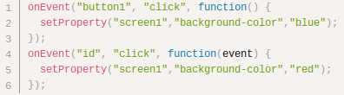 | Earn Point? Yes / No  Why?
Example Algorithm 2  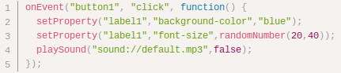 | Earn Point? Yes / No  Why?
Example Algorithm 3  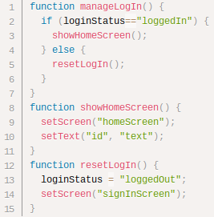 | Earn Point? Yes / No  Why?
Example Algorithm 4  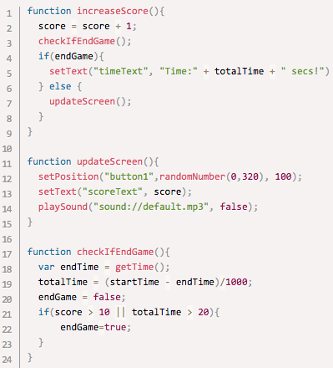 | Earn Point? Yes / No  Why?
Example Algorithm 5  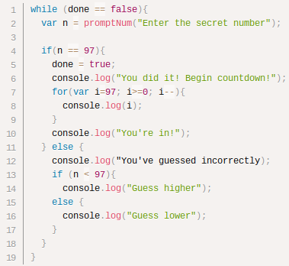 | Earn Point? Yes / No  Why?

Abstraction on the Create PT (20 mins)

Is it a Good Abstraction?
Abstraction - College Board Definitions The AP course framework includes the following statements related to abstraction and programming that are relevant for the Create PT:
- Multiple levels of abstraction are used to write programs (EU 2.2)
- The process of developing an abstraction involves removing detail and generalizing functionality. (EK 2.2.1A)
- (Student can) Use abstraction to manage complexity in programs. (LO 5.3.1 [P3])

What it means: Abstractions manage complexity. Programming abstractions make it easier to write complex programs. The AP reader is checking that you can create, identify, and describe an abstraction that manages complexity in your code.

- Something You Wrote: The code you submit as your abstraction should be something that you wrote entirely on your own. You cannot submit code that a partner helped you write.
- Good Abstraction Choice - Functions that you wrote: A function that you wrote means a function that you defined, named, and wrote code for (i.e code that starts function myFunc(){ ... }). Your function can demonstrate managing complexity if it either (or both):
  - gets called from multiple different places in your code
  - has a parameter that generalizes some behavior (and also probably called from several places)

- Bad Abstraction Choice: onEvent and other built-in programming language/environment features
- onEvent does NOT count as a “student-developed abstraction”. OnEvent is provided by the programming environment and the code contained within it is used in a single location in your code. Therefore it does not in any way manage complexity.  - Identifying onEvent as an abstraction is the most common way to lose credit on this question.  - Variables by themselves are not a data abstraction | 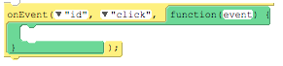  onEvent IS NOT an abstraction
  - Anything that is an existing abstraction provided by the language that you are simply using. For example: loops and logical structures are not student developed abstractions

Does it Count? - Abstraction Edition
The AP reader has to judge strictly from the code you include in your response to 2d whether it meets the requirements. They will assume that all of the screen elements and variables the code refers to exist, and that the code is the working code from your video.

Row 7 - Response 2D: The points for Row 7 of the scoring guidelines are awarded strictly for the code segment selected.
Criteria | Decision Rules | Scoring Notes
- Selected code segment is a student-developed abstraction. | Responses that use existing abstractions to create a new abstraction, such as creating a list to represent a collection (e.g., a classroom, an inventory), would earn this point.  Do NOT award a point if any one of the following is true:  - the response is an existing abstraction such as variables, existing control structures, event handlers, APIs;  - the code segment consisting of the abstraction is not included in the written responses section or is not explicitly identified in the program code section; or  - the abstraction is not explicitly identified (i.e., the entire program is selected as an abstraction, without explicitly identifying the code segment containing the abstraction). | - The following are examples of abstractions (EK 5.3.1):  - Procedures  - Parameters  - Lists  - Application program interfaces (APIs)  - Libraries  - Lists and other collections can be treated as abstract data types (ADTs) in developing programs. (EK 5.5.1I)

Evaluate Abstractions! Each of the code segments below shows a portion of code with a rectangle around it. Sometimes additional code is included to help you understand the context of that abstraction (for example, to determine whether the abstraction helps manage complexity).

For each example below respond to 3 things:
- Earn Point? Yes / No - Would the selected code segment earn the point for row 7?
- Why? - note why it does or doesn’t earn the point
- Manages Complexity? Yes / No - based on what you can see, are you able to argue that the abstraction manages complexity?

Example 1  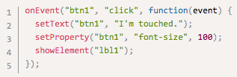 | Earn Point? Yes / No  Why?  Manages Complexity? Yes / No
Example 2  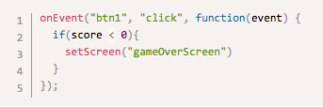 | Earn Point? Yes / No  Why?  Manages Complexity? Yes / No
Example 3  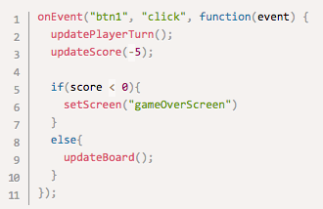 | Earn Point? Yes / No  Why?  Manages Complexity? Yes / No

Example 4  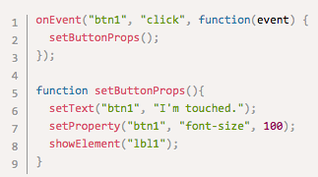 | Earn Point? Yes / No  Why?  Manages Complexity? Yes / No
Example 5  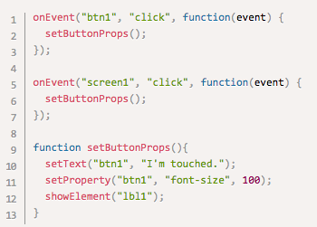 | Earn Point? Yes / No  Why?  Manages Complexity? Yes / No
Example 6  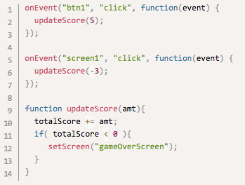 | Earn Point? Yes / No  Why?  Manages Complexity? Yes / No

“Narrow it Down” (15 mins)

You should assume that you’re not going to have enough time to complete the “perfect” project for the Create PT. This is okay because you can get full credit for a programming project that feels incomplete as long as it has working elements. While a large or more complete project is satisfying, your score is based mostly on the written responses, which is how you demonstrate that you understand the concepts covered on the Create PT.

All your project actually needs to include is:
- One working feature that you can demonstrate in your video
- An algorithm
- An abstraction

You will make the project much easier if you narrow down your original idea into a simpler target project. This will give you more time to complete the written responses or make smaller improvements.

How to Narrow it Down: Narrowing it down means identifying the sub-tasks or sub-problems that meet the PT requirements. Here’s a few strategies to help you do that:

- Get to the Algorithm: Split your project into individual components that will likely require an algorithm that meets the Create PT requirements. Each of these components individually could be your entire project.

- Pick One Part of a Bigger Idea: Think about your project as a set of programming tasks that each solve part of a larger problem. Some of these individual tasks might suffice for the Create PT. You can just pick one part of a big idea that meets the requirements that you think you can program in the time allotted.

- Minimal Design Mode - looks don’t matter: Complex visual design work in Design Mode (setting colors, fonts, spacing, etc.) will likely NOT meet any of the requirements for the Create PT. Don’t worry about how your app looks until after you already have code that will let you complete the written responses.

Practice Narrowing it Down
Below are three descriptions of potential projects that another CS Principles student is considering. For each write:
- Two or three ways they could narrow down the project using the tips above
- Opportunities to write an algorithm in their project even after it’s been narrowed down.

Project 1: Tic-Tac-Toe
“Here’s my idea: I want to build a tic-tac-toe game. The user creates an account if they don’t already have one and are taken to the main game board. From there the player will play against the computer in either easy, intermediate, or advanced mode, so I will need to write the code for the computer player. When the game is over their lifetime win total is updated. I will also keep track of how long the game took.”

Ways to narrow down the project (2 or 3) | Algorithm opportunities

Project 2: Health App
“I volunteer at my local health clinic so I want to build a health app. The user can record information about what they eat, how much they sleep, how much they exercise, and information like their blood pressure and weight. Based on the information provided the app will provide recommendations to the user about how they can improve their health for both diet and exercise. Users can also personalize the look of the app with different theme colors.”

Ways to narrow down the project (2 or 3) | Algorithm opportunities

Project 3: Sports Stats
“I think that I’ll build an app that allows the user to quickly record stats during a basketball game. The app will show a picture of the court. The user taps on the court to indicate something happened there. They are presented with a quick menu of options like: shot attempt, foul, steal, rebound, etc. then they select from another list which player did it. At the end of the game it displays a stat sheet for all of the players and the stats for that game.”

Ways to narrow down the project (2 or 3) | Algorithm opportunities

Bring it All Together (15 mins)

With an understanding of the major components of the Create PT, you are ready to start brainstorming projects. While you have at least 12 class hours to complete the task, keep in mind that those 12 hours also must account for time to make your video and complete the written responses. We recommend budgeting at least 5 hours to complete the video and written responses, and so it is highly recommended that you prepare to do a project in which the programming / coding can be completed in 6-7 hours. You want projects with the following features.

- Personally Relevant: Pick projects you are actually interested in building.
- Clear Purpose: Aim for a simple program whose purpose can be stated in one sentence. For example:
  - The purpose of my program is ______.
  - My app does ______.
  - My program lets a user ______.
  - My app is a ______.
- Narrowed Down: Repeat the “Narrow it Down” process with your own ideas. A good rule of thumb is that you’ll want to be able to have a first draft of your algorithm within two hours of starting to program.
- No New Programming Skills: Make sure you already have the programming skills necessary to complete the project. Be flexible. With some creativity you can likely use the skills you’ve already learned to make many different types of projects. Avoid taking on new programming environments or concepts as part of the Create PT.

Brainstorm Project Ideas
Brainstorm one or two project ideas for the Create PT. Afterwards you’ll share ideas with a classmate for feedback.
Project Idea | Classmate Feedback
Purpose:  Ways to Narrow it Down:  Algorithm Opportunities:  Confidence you have skills to do this it in time allotted?: | Use the list above to give feedback on the idea.
Purpose:  Ways to Narrow it Down:  Algorithm Opportunities:  Confidence you have skills to do this it in time allotted?: | Use the list above to give feedback on the idea.
Algorithm Includes two or more algorithms….

Sub-algorithm 1

Sub-algorithm 2
Program purpose
(remember: your video should show this)

Development process overall
Difficulty/opportunity #1
Circle one: feedback • testing • reflection
(how it was resolved, incorporated into project)

Difficulty/opportunity #2
Circle one: feedback • testing • reflection
(how it was resolved, incorporated into project)
Identify main algorithm (name of function, location in code, etc.)

Row 1
Row 2
Row 3
Row 3
Response 2c
Rows 4, 5
Create PT Progress / Check-in organizer

This organizer is inspired by the work of Jill Westerlund at abstractingCS.com. Recreated and modified with permission.
Your developed abstraction
(name of function(s) you wrote)

How does it manage complexity?
Examples:
• Able to reuse functionality?
• Problem broken down into functions and sub-functions?
• Generalizes specific behavior?
Rows 7,8
How does it function? (explain any mathematical or logical concepts used).
How does it relate to overall purpose?

Explain how at least one of the two (1) uses Mathematical or Logical concepts (2) can explain how it functions independently.

Row 6
Row 5
Rows 4, 5
Row 5
2a
2b
2c
2d

Create PT Completion Timeline
Before you start, you should think about how you are going to allocate your time for the 12 hours provided for the task.
Below is a sample timeline that you can use to plan out how you will complete the Create Performance Task.
Hour | Suggested Activity | Your Plan
1 - 2 | Begin building a program for a project you brainstormed. Carefully monitor whether you will finish enough of your project in time.  Write down one opportunity or difficulty you’ve encountered for prompt 2b.  Goal: you should be confident after this first round of development that you’ll be able to meet the requirements for algorithms (2c) and abstraction (2d).  Use the Create PT Progress / Check-in organizer to test yourself about whether you are on track.
3 - 4 | Keep working. Check in after hour 4 once again on whether you are on track to complete responses. You should ideally know:  - The abstraction you will write about  - The algorithm you will write about  Write down a second opportunity or difficulty you’ve encountered for prompt 2b.  Use the Create PT Progress / Check-in organizer to test yourself about whether you are on track.
5 - 7 | Finalize all programming. After this point you shouldn’t be writing more code (beyond simple touch ups)
8 | Complete prompt 2b, using the notes you took as you were programming.
9 | Record video of your program running and complete response 2a
10 | Complete 2c describing your algorithm
11 | Complete 2d describing your abstraction
12 | Complete the task  - Review the submission materials  - Check your responses against the scoring guidelines  - Upload your video, written response, and program code to the digital portfolio  Goal: At the end of this day, your Create PT is submitted!

Note: The timeline above is just a guideline. You may complete the performance task on a different schedule. Make sure to leave enough time to complete your computational artifact and write-up.

Create PT Guidelines
Video Submit one video in .mp4, .wmv, .avi, or .mov format that demonstrates the running of at least one significant feature of your program. Your video must not exceed 1 minute in length and must not exceed 30MB in size

Prompt 2a. Provide a written response or audio narration in your video that:
- identifies the programming language;
- identifies the purpose of your program; and
- explains what the video illustrates.
(Must not exceed 150 words)
Advice: For resources on how to make your video, head to https://studio.code.org/s/csp-create/stage/1/puzzle/2. Here are the most important things to remember for your video and prompt 2a.

- Video Runs Continuously: Your video must run continuously and show your actual code running. It can’t just be a series of screenshots.
- Show One Feature: Your program does NOT need to be complete so long as you can demonstrate one major feature that’s running.
- Describe the Purpose: The purpose of your program is the intended goal or objective of the program. In other words, it’s “what” the program is supposed to do. If you made a game, an app, or some other kind of project, just quickly describe “what” kind of program it is and how it would be used / played.
- Connection to Video: Make sure that you can connect the purpose of your program to what is shown in the video. If you only have one feature working then describe the purpose of the feature.
Response 2a Checklist

Video
- Video runs continuously (it cannot be a series of screenshots)
- Video is less than 60 seconds long and less than 30MB in size
- Video demonstrates one running feature of the program

Written Response
- Response identifies the programming language used
- Identifies the purpose of the program
- Describes the feature(s) shown in the video and their connection to the purpose of the program
- May be audio commentary in your video. Carefully follow this checklist even if you use audio commentary.

2b. Describe the incremental and iterative development process of your program, focusing on two distinct points in that process. Describe the difficulties and / or opportunities you encountered and how they were resolved or incorporated. In your description clearly indicate whether the development described was collaborative or independent. At least one of these points must refer to independent program development. (Must not exceed 200 words)
Advice: There are many individual pieces of information you need to fit in this response. Use the checklist at the bottom carefully to make sure you don’t miss any. Here are the most important pieces to remember:

- Don’t Forget the Overall Process: You should reference your development process as a whole, NOT just two points in time. Your response should reflect an iterative process of identifying and solving problems focusing on programming decisions (i.e. writing a function to display score) vs design decisions (i.e. how to layout a screen).
- Difficulties / Opportunities: You need to describe two distinct difficulties / opportunities you encountered
  - A difficulty is likely either a bug in your code or a difficult design problem you needed to work out.
  - An opportunity is likely an idea or realization you had as you developed your code that led to new ideas.
- Feedback / Testing / Reflection: You should clearly describe HOW you identified the two difficulties / opportunities - was it through testing your program out? Personal reflection? Through feedback from a peer?
- Independent or Collaborative: If you developed your program completely independently, you need to say so - don’t assume the reader will know. If you developed your program collaboratively, some parts need to be done on your own. For this response make sure:
  - You clearly indicate which parts were done collaboratively
  - No identifying information is in your response. It’s ok to say “I worked with a partner on this part of the program…”. Don’t say “I worked with Jesse S to create this part of the program....”
  - You clearly state which of the difficulties/opportunities described here was done independently on your own (could be both, but at least one).
Response 2b Checklist

Overall Development
- Response describes the overall development process, not only two key points.
- Response indicates whether you completed the project independently or with a partner. (note: this indication can be incorporated throughout your response and in comments within your code as well).

First Difficulty / Opportunity
- Response describes one difficulty / opportunity encountered early in the development process
- Response describes source of difficulty / opportunity as either feedback, testing, or reflection
- Response indicates how it was incorporated / solved, including whether you wrote the code independently.

Second Difficulty / Opportunity
- Response describes one difficulty / opportunity encountered later in the development process
- Response describes source of difficulty / opportunity as either feedback, testing, or reflection
- Response indicates how it was incorporated / solved, including whether you wrote the code independently.
- If first Difficulty / Opportunity WAS NOT solved independently, then this one must be

2c. Capture and paste a program code segment that implements an algorithm (marked with an oval in section 3 below) and that is fundamental for your program to achieve its intended purpose. This code segment must be an algorithm you developed individually on your own, must include two or more algorithms, and must integrate mathematical and/or logical concepts. Describe how each algorithm within your selected algorithm functions independently, as well as in combination with others, to form a new algorithm that helps to achieve the intended purpose of the program. (Must not exceed 200 words)
Advice: Review the “Is it a Good Algorithm” section above for lots of helpful tips on how to choose your algorithm. Here’s the most important points.

- You Wrote it: You need to have written the code of your algorithm entirely on your own (not with a partner)
- Copy and Paste it: You must paste your actual algorithm code as part of this response.
- A Parent and Two Children: Your selected algorithm (the “parent”) needs to have two included algorithms (the “children”). See Example Algorithms 4 and 5 for ideas about how this might look.
- Mathematical / Logic Concepts: At least one included algorithm needs to use mathematical and/or logical concepts.
- Break Into Functions: To make it easier to refer to individual parts of your algorithm give the selected and included algorithms their own functions. Example Algorithm 4 is written in this way.
- Describe “how”, not just “what”: You need to talk about how your code works, not just what the user will see when it runs. Do this by referring to the actual variables names, programming constructs, strings, and so on, that are visible in your code snippet. For example:

“The algorithm I selected is signInUser() which handles the user login process in my app which has two key parts: checkName() and startHomeScreen(). checkName has an if-statement that checks to see whether the name entered in the usernameTxt textbox is equal to ‘MrSillyMan’ or ‘MsFunnyGal’. If it is then it sets the accessGranted variable to true, otherwise false. The startHomeScreen() function checks the accessGranted variable and returns the login screen if false, otherwise it proceeds to show the home screen for the user.”
Response 2c Checklist

Overall
- You wrote all algorithm code yourself
- Response includes copy-pasted versions of code for main and sub-algorithms with ovals around them
- Response identifies the selected algorithm (parent) and at least two included algorithms (children).

Included algorithm 1
- Clearly identifies the code for the algorithm (where in the code, function name, line numbers, etc)
- Explains what the algorithm does independently
- Describes how the code of the algorithm works
- Uses mathematical or logical concepts

Included algorithm 2
- Clearly identifies the code for the algorithm (where in the code, function name, line numbers, etc).
- Explains what the algorithm does independently
- Describes how the code of the algorithm works
- Uses mathematical or logical concepts

Selected Algorithm
- Clearly identifies the code for the selected algorithm (where in the code, function name, line numbers, etc).
- Describes how selected algorithm combines included algorithms.
- Explains how selected algorithm helps to achieve the overall purpose of the program

2d. Capture and paste a program code segment that contains an abstraction you developed individually on your own (marked with a rectangle in section 3 below). This abstraction must integrate mathematical and logical concepts. Explain how your abstraction helped manage the complexity of your program. (Must not exceed 200 words)
Advice: Review the “Is it a Good Abstraction?” section above for tips on how to choose your abstraction. Here’s the most important points.

- Choose a Function: Unless you feel confident about another abstraction, choose a function - not an onEvent, but a function you defined and named yourself.
- You Wrote it: You need to have written the code of your abstraction entirely on your own (not with a partner)
- Copy and Paste it: You must paste your actual abstraction code as part of this question submission.
- Manages Complexity: Make sure you can describe how your abstraction helps manage complexity in your program.
- Make a contrasting argument: explain how your program would be more complex to read, write, or reason about if you had not created your abstraction.
- Mathematical and Logical Concepts: While you should aim to include these in your abstraction, this is NOT explicitly assessed by the Scoring Guidelines for 2019.
Response 2d Checklist

Overall
- You wrote all abstraction code yourself (it’s not an onEvent block, but a function you defined and named)
- Response includes copy-pasted versions of code for abstraction with a rectangle around it
- Response identifies the abstraction by name
- You explicitly describe HOW the abstraction manages complexity (e.g. by explaining how your code would be more complex to write or reason about without the abstraction)

3. Program Code
Capture and paste your entire program code in this section.
› Mark with an oval the segment of program code that implements the algorithm you created for your program that integrates other algorithms and integrates mathematical and/or logical concepts.
› Mark with a rectangle the segment of program code that represents an abstraction you developed.
› Include comments or acknowledgments for program code that has been written by someone else.
Advice: For resources on how to make a PDF of your program code head to https://studio.code.org/s/csp-create/stage/1/puzzle/2. Here’s the most important things to remember:

- Making Your PDF: Use CodePrint to make a PDF of your program. It’s designed specifically for the Create PT. You can find it from the link above.
- Marking Your Algorithm: Make sure you place an oval around all parts of your algorithm (selected and included).
- Marking Your Abstraction: Place your rectangle around the code where you create your abstraction (e.g. define a function) not where you use the abstraction (e.g. call a function).
- Commenting and Collaboration: You may work with a partner on the Create PT, but you must clearly indicate which parts you completed independently and which you completed together by using comments. For example:
// I completed the section below with my collaborative partner
// I completed this section independently
// I have extended code found at [URL]. The code below is my additions
Remember that your algorithm and abstraction need to be created entirely independently.

- Citing Images: If you use code or images made by someone else (for example that you found online) then you should cite those resources as well. Again you can use comments.
// The images used in this app came from:
// [1] bird image - http://name-of-site.com/path/to/image.jpg
// [2] flower image - http://site.com/path/to/flower.jpg

Much of the content of this this guide was inspired by Jill Westerlund at the Abstracting CS blog. We are grateful for Jill’s ingenuity and generosity.

